SETTING UP THE APPLICATION ENVIRONMENT IBM CLOUD CLI INSTALLATION

|  |  |
| --- | --- |
| **DATE** | 27 October 2022 |
| **TEAM ID** | PNT2022TMID52830 |
| **PROJECT NAME** | Inventory Management System for Retailers |

# RUN THE FOLLOWING COMMAND AS ADMINISTRATOR IN POWERSHELL:

Command :

iex(New-Object Net.WebClient).DownloadString(‘<https://clis.cloud.ibm.com/install/powershell>’)

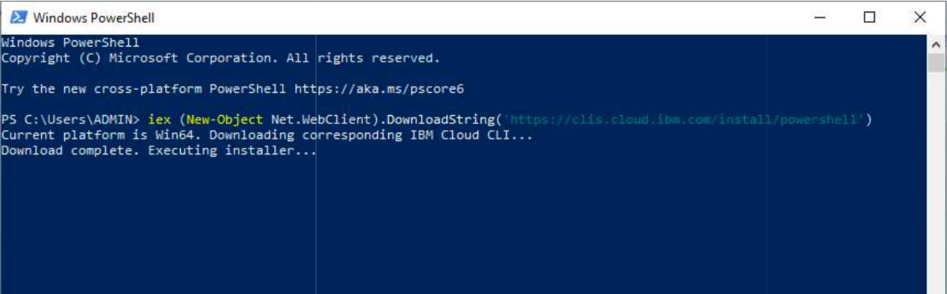

# CHECK IF IBM CLOUD CLI IS CORRECTLY INSTALLED:

Command : ibmcloud help

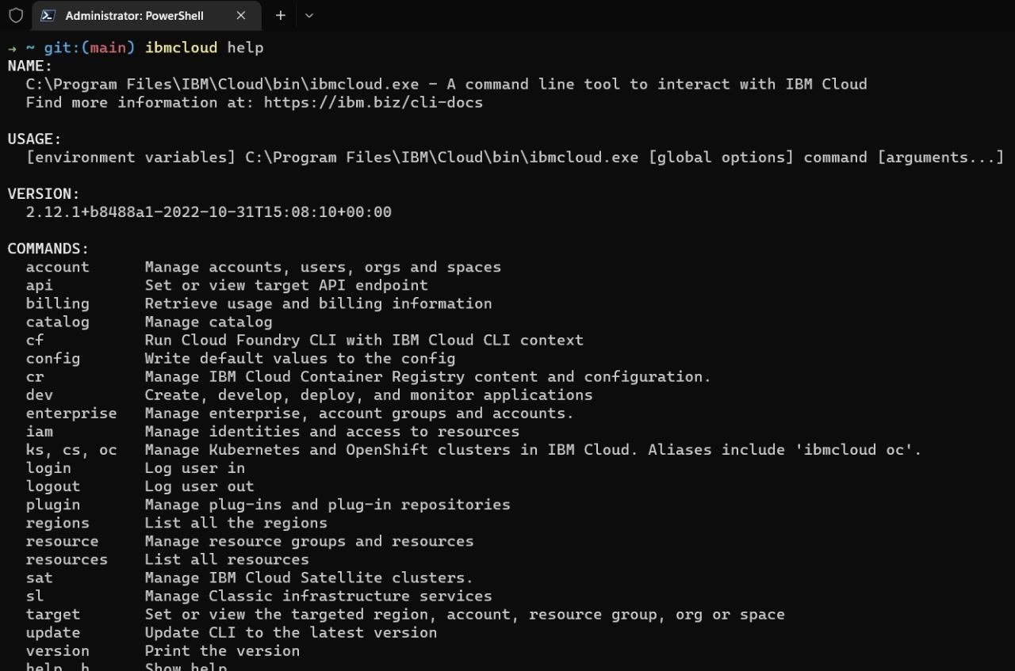

# CONFIGURE OUR ENVIRONMENT:

Command : ibmcloud login

